|  |  |
| --- | --- |
| **C:\Users\faisal\Pictures\NSU_pic_download\n91267046457_2661.jpg**  **CSE 311L(Database Management System)**  **LAB-Week 02** |  |

Topics:

* Basic SELECT Statement
* Selecting All Columns, Specific Columns
* Arithmetic Expressions, Using Arithmetic Operators, Parenthesis
* Defining a Column Alias

**BASIC QUERIES IN SQL**

* SQL has one basic statement for retrieving information from a database; the SLELECT statement
* This is *not the same as* the SELECT operation of the relational algebra
* Important distinction between SQL and the formal relational model;
* SQL allows a table (relation) to have two or more tuples that are identical in all their attribute values
* Hence, an SQL relation (table) is a *multi-set* (sometimes called a bag) of tuples; it is *not* a set of tuples
* SQL relations can be constrained to be sets by using the CREATE UNIQUE INDEX command, or by using the DISTINCT option
* Basic form of the SQL SELECT statement is called a *mapping* of a *SELECT-FROM-WHERE block*

SELECT <attribute list> FROM <table list> WHERE <condition>

* <attribute list> is a list of attribute names whose values are to be retrieved by the query
* <table list > is a list of the relation names required to process the query
* <condition> is a conditional (Boolean) expression that identifies the tuples to be retrieved by the query

**SIMPLE SQL QUERIES**

Basic SQL queries correspond to using the following operations of the relational algebra:

SELECT

PROJECT

JOIN

**Example of a simple query on one relation (company2.sql)**

**Basic SELECT Statement**

SELECT \*|{[DISTINCT] *column*|*expression* [*alias*],...}

FROM *table;*

**Arithmetic Operators**

SELECT last\_name, salary, 12\*(salary+100)

FROM emps;

**Using Column Aliases**

SELECT last\_name "Name", salary\*12 "Annual Salary"

FROM emps;

**Activity 01:**

Write a query that displays the last name , weekly salary, department number of the employees. Name the salary column as "Weekly Salary".

Run: Populate the table with data given and running company,sql in the mysql promt

All subsequent examples uses COMPANY database as shown below:

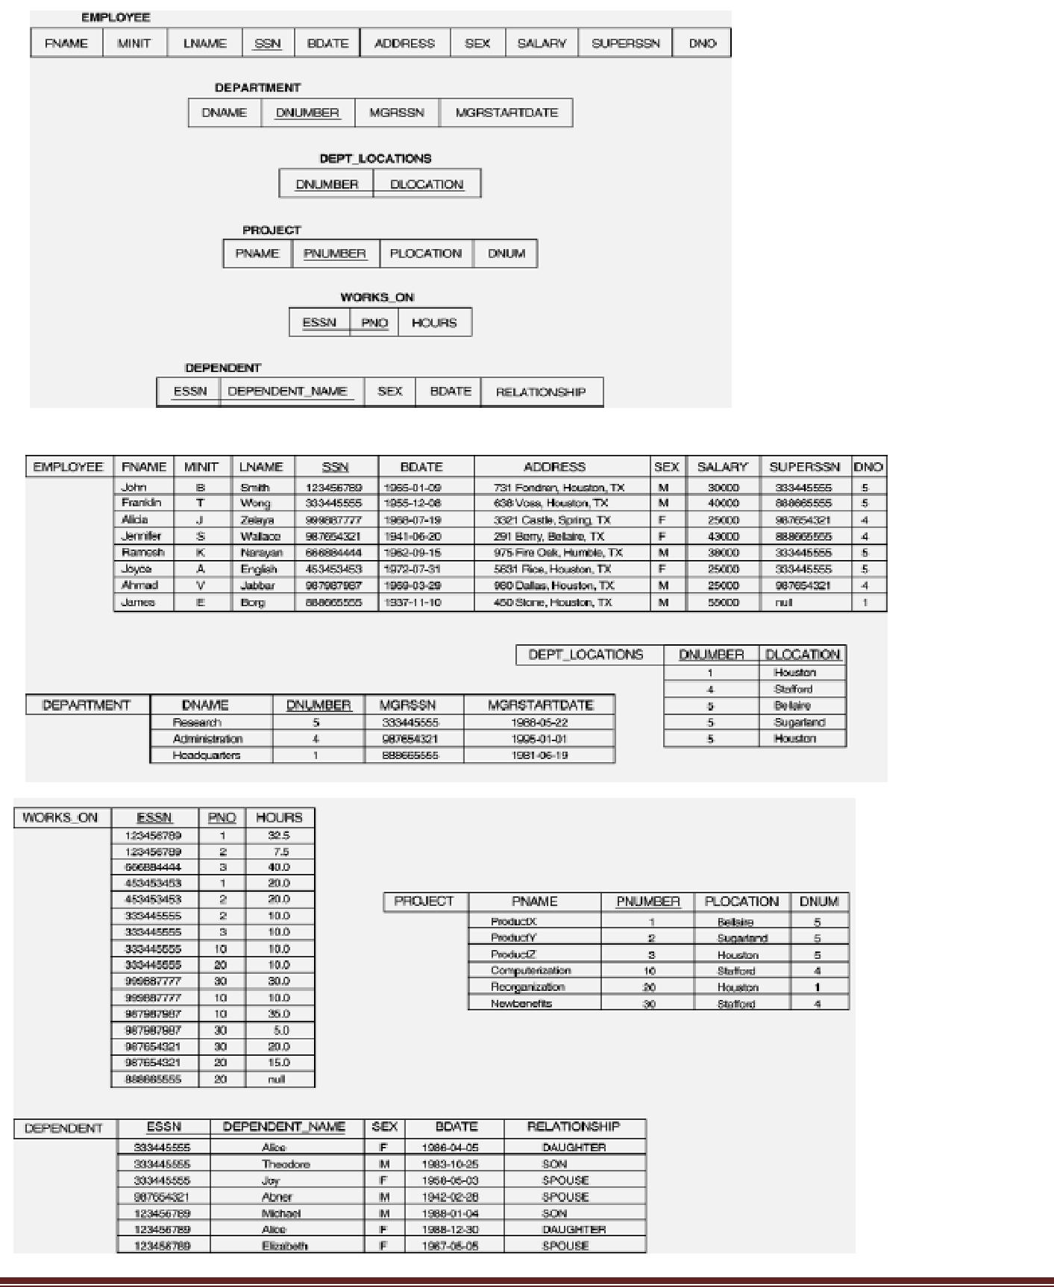

**Example of a simple query on one relation**

**Query 0: Retrieve the birth date and address of the employee whose name is 'John B.**

**Smith'.**

Q0: SELECT BDATE, ADDRESS FROM EMPLOYEE

WHERE FNAME='John' AND MINIT='B‘ AND LNAME='Smith‘

The SELECT-clause specifies the projection attributes and the WHERE-clause specifies the selection condition However, the result of the query may contain duplicate tuples

**Example of a simple query on two relations**

**Query 1: Retrieve the name and address of all employees who work for the 'Research'**

**department.**

Q1: SELECT FNAME, LNAME, ADDRESS FROM EMPLOYEE, DEPARTMENT WHERE DNAME='Research' AND DNUMBER=DNO

Similar to a SELECT-PROJECT-JOIN sequence of relational algebra operations (DNAME='Research') is a selection condition (corresponds to a SELECT operation in relational algebra) (DNUMBER=DNO) is a join condition (corresponds to a JOIN operation in relational algebra)

**Example of a simple query on three relations**

**Query 2: For every project located in 'Stafford', list the project number, the controlling department number, and the department manager's last name, address, and birth date.**

Q2: SELECT PNUMBER, DNUM, LNAME, BDATE, ADDRESS FROM PROJECT, DEPARTMENT, EMPLOYEE WHERE DNUM=DNUMBER AND MGRSSN=SSN AND PLOCATION='Stafford'

In Q2, there are two join conditions The join condition DNUM=DNUMBER relates a project to its controlling department The join condition MGRSSN=SSN relates the controlling department to the employee who manages that department

**ALIASES, \* AND DISTINCT, EMPTY WHERE-CLAUSE**

* In SQL, we can use the same name for two (or more) attributes as long as the attributes are in different relations
* A query that refers to two or more attributes with the same name must qualify the attribute name with the relation name by prefixing the relation name to the attribute name **Example:** EMPLOYEE.LNAME, DEPARTMENT.DNAME
* Some queries need to refer to the same relation twice. In this case, aliases are given to the relation name

**Example**

**Query 3: For each employee, retrieve the employee's name, and the name of his or her**

**immediate supervisor.**

Q3: SELECT E.FNAME, E.LNAME, S.FNAME, S.LNAME FROM EMPLOYEE E S WHERE E.SUPERSSN=S.SSN

In Q3, the alternate relation names E and S are called aliases or tuple variables for the EMPLOYEE relation We can think of E and S as two different copies of EMPLOYEE; E represents employees in role of supervisees and S represents employees in role of supervisors

Aliasing can also be used in any SQL query for convenience. Can also use the AS keyword to specify aliases

Q3: SELECT E.FNAME, E.LNAME, S.FNAME, S.LNAME FROM EMPLOYEE AS E, EMPLOYEE AS S WHERE E.SUPERSSN=S.SSN

**UNSPECIFIED WHERE-clause**

A missing WHERE-clause indicates no condition; hence, all tuples of the relations in the FROM-clause are selected. This is equivalent to the condition WHERE TRUE

Example:

**Query 4: Retrieve the SSN values for all employees.**

Q4: SELECT SSN FROM EMPLOYEE

If more than one relation is specified in the FROM-clause and there is no join condition, then the CARTESIAN PRODUCT of tuples is selected

Example:

Q5: SELECT SSN, DNAME FROM EMPLOYEE, DEPARTMENT

**Note:** It is extremely important not to overlook specifying any selection and join conditions inthe WHERE-clause; otherwise, incorrect and very large relations may result

**USE OF \***

To retrieve all the attribute values of the selected tuples, a \* is used, which stands for all the attributes

Examples:

R**etrieve all the attribute values of EMPLOYEES who work in department 5.**

Q1a: SELECT \* FROM EMPLOYEE WHERE DNO=5

**Retrieve all the attributes of an employee and attributes of DEPARTMENT he works in for every employee of ‘Research’ department.**

Q1b: SELECT \* FROM EMPLOYEE, DEPARTMENT WHERE DNAME='Research'

AND DNO=DNUMBER

**USE OF DISTINCT**

SQL does not treat a relation as a set; duplicate tuples can appear. To eliminate duplicate tuples in a query result, the keyword DISTINCT is used

Example: the result of **Q1c** may have duplicate SALARY values whereas **Q1d** does not have any duplicate values

Q1c: SELECT SALARY FROM EMPLOYEE

Q1d: SELECT **DISTINCT**

SALARY FROM EMPLOYEE

**Activity 02:**

Find the results in SQL for these queries:

1. Find the first name and Last name of the employees who are supervised by “Franklin Wong’?
2. Find the last and first name of the employees who have a dependent with the same first name as themselves?
3. For each department find out the department manager’s last name, his start date and the name his dependents (if any)?